**Lab 8 – SQL**

**Each problem is worth one point. This lab is worth a total of 15 points.**

**From this lab forward, please notice if a result table is in a particular order. If it is you must use the order by clause. Failure to do so will result in 0 points for that specific problem.**

**Place all answers into ONE .sql file and upload to Canvas.**

**Table names are not given. You must determine the correct tables.**

**\*\*\*\* Use the Student table space for the following questions \*\*\*\***

**1. Display the lowest priced course. You must use a subquery.**



**2. Display the course cost that is between the lowest and the highest priced course. You**

**must use two subqueries.**



**3. Display the course cost that is larger than the average of the course costs. You must use a**

**subquery.**



**4. Display the earliest enrollment date.**



**5. Add 30 days to the earliest enrollment date.**



**\*\*\*\* Use the AP table space for the following questions \*\*\*\***

**6. Display all invoice amounts that are smaller than the largest invoice amount for vendor**

**123.**

**Partial result table (82 rows total)**

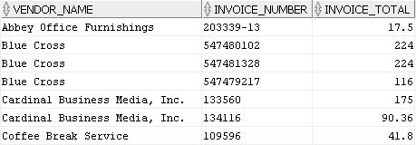

**7. Display the vendors without invoices. Use a subquery.**

**Partial result table (88 rows total)**

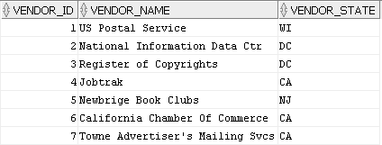

**\*\*\*\* Use the Student table space for the following questions \*\*\*\***

**8. Use double ampersand substitution within a Where clause. Display all student first names**

**and last names that start with a capital ‘M’.**

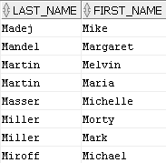

**9. Display all course costs that are greater than the lowest course cost. No hard-coding of**

**costs will be allowed.**

**Partial result table (26 rows total)**



**\*\*\*\* Use the AP table space for the following questions \*\*\*\***

**10. Display each invoice amount that is higher than the vendor’s average invoice amount.**

**You must use a correlated subquery.**

**Partial result table (36 rows total)**

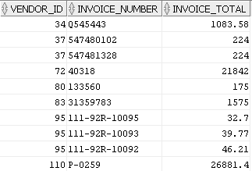

**11. Display all vendors that have at least one invoice. Use an inner join.**

**Partial result table (114 rows total)**

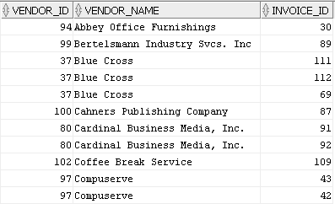

**12. Display the number of invoices per vendor.**

**Partial result table (34 rows total)**

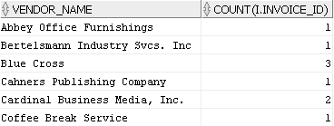

**13. Display all vendors that have a vendor contact last name length greater than the vendor**

**contact first name and the state must be either California or New Jersey.**

**Partial result table (38 rows total)**

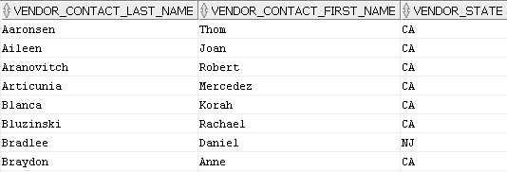

**14. Display all vendors that have an apostrophe (‘) in their name. You must use the INSTR**

**function.**

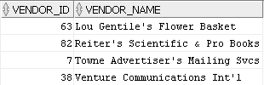

**15. Display all vendors that do not have a space in their name. You must use the**

**REGEXP_SUBSTR function.**

